**PROJECT TITLE: FLOOD MONITORING AND EARLY WARNING**

**PHASE 4: DEVELOPMENT PART- II**

**OBJECTIVE:**

Our objective of this Development Part II is to provide a comprehensive and user-friendly platform for real-time flood monitoring and early warning, aimed at enhancing safety and preparedness for individuals and communities. Leveraging Visual Studio for coding and Microsoft Edge for testing, we are dedicated to delivering up-to-the-minute data on weather conditions, river levels, and potential flood threats, empowering users to take proactive measures and protect what matters most. Through our advanced system, we aim to minimize the impact of flooding disasters, ultimately saving lives and safeguarding property.

**VISUAL STUDIO CODE:**

Visual Studio Code, often referred to as VS Code, is a popular and versatile source code editor that's widely used for software development. It's known for its flexibility, speed, and a rich ecosystem of extensions, making it a top choice for many developers.

"Visual Studio Code (VS Code) is a lightweight, open-source code editor with powerful features for an enhanced coding experience. With its speed and efficiency, it's a favorite among developers for a wide range of programming languages. Its extensible architecture allows users to customize and enhance their development workflow with a wide variety of extensions, making it a go-to choice for productivity and collaboration."

VS Code is a versatile tool that suits a broad spectrum of coding needs, from web development to system programming, and it's favored for its user-friendly interface and robust set of features.

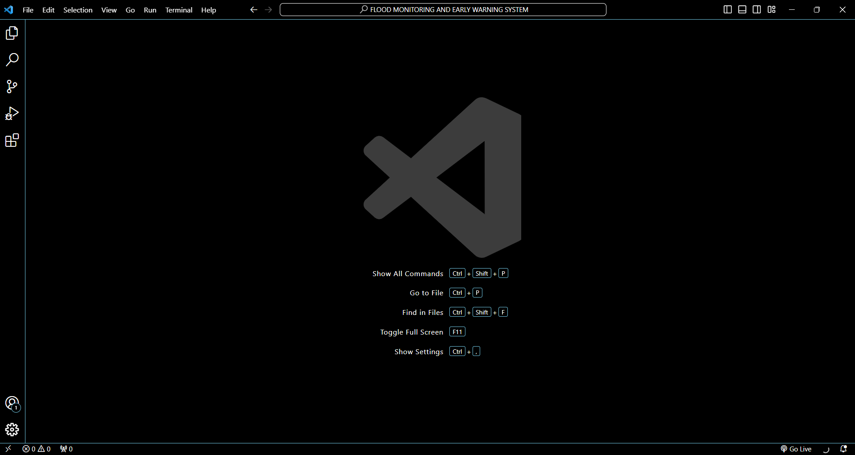

**CODE AND IT’S EXPLANATION:**

* **HTML**

The HTML (index.html) file lays the foundation for the webpage's structure and content. It begins by defining the document type and including a reference to an external CSS stylesheet for styling.

<!DOCTYPE html>

<html>

<head>

    <title>Flood Monitoring And Early Warning System</title>

    <link rel="stylesheet" type="text/css" href="style.css">

</head>

<body>

    <h1>Flood Monitoring and Early Warning System</h1>

    <pre class="pre">Experience peace of mind with our advanced Flood Monitoring and Early Warning system.

         We keep a vigilant eye on weather conditions, providing real-time alerts to keep you and your community safe from potential flooding disasters.

         Stay ahead of the storm, take proactive measures, and safeguard what matters most to you. Your safety is our top priority, and we've got you covered."</pre>

    <img src="https://s01.sgp1.cdn.digitaloceanspaces.com/article/171892-mfhhyptrto-1647955322.jpg">

    <div class="container">

        <h2 id="real">Real-time Data</h2>

        <div class="data-container">

            <div class="data-box">

                <p class="text"><strong>Distance:</strong></p>

                <p class="load">Loading...</p>

            </div>

            <div class="data-box">

                <p class="text"><strong>Temperature:</strong></p>

                <p class="load">Loading...</p>

            </div>

            <div class="data-box">

                <p class="text"><strong>Humidity:</strong></p>

                <p class="load">Loading...</p>

            </div>

        </div>

        <div id="alertbox">

        <h2 id="alerttext">Alerts:</h2>

        <p class="alert" id="alertMessage">Loading...</p>

        </div>

    </div>

    <p id="end">&nbsp;</p>

    <pre id="quote">"Alert today, alive tomorrow. Our system keeps you ahead of disaster."</pre>

    <p id="end">&nbsp;</p>

</body>

</html>

The main content of the page is divided into several key sections:

1. **Header Section:**

The page opens with a prominent `<h1>` heading that boldly announces the system's name, "Flood Monitoring and Early Warning System." Below the heading, a `<pre>` element presents a detailed description of the system's purpose. This description is thoughtfully formatted with line breaks and consistent spacing, ensuring a clear and organized presentation. An `<img>` tag is used to display an image that likely represents a flood-related scenario.

1. **Data Display Section:**

This section, encapsulated within a `<div>` element with the class "container," provides a visually distinct area for the real-time data display. It starts with an `<h2>` subheading labeled "Real-time Data." Within this sub-section, the actual data is organized using a flexbox container structure. Each data point (e.g., distance, temperature, humidity) is contained within a `<div>` element with the class "data-box." Each "data-box" consists of a label (e.g., "Distance:") and a placeholder text (e.g., "Loading...") to indicate that the data will be dynamically loaded. Following the real-time data display, there's a dedicated section with the ID "alertbox," which includes an "Alerts" heading and a placeholder message.

* **CSS STYLING:**

The CSS stylesheet(style.css), linked in the HTML file, provides the visual styling for the page.

body {

    font-family: Arial, sans-serif;

    text-align: center;

    bgcolor:"#e3e0ff";

}

.container {

    margin: 20px;

}

h1 {

    font-size: 50px;

    background-color: aquamarine;

    font-family: Georgia, 'Times New Roman', Times, serif;

    color: #060000;

}

.pre {

    color:#03038f;

    font-size:22px;

    font-family: 'Franklin Gothic Medium', 'Arial Narrow', Arial, sans-serif;

}

#real {

    font-family: Georgia, 'Times New Roman', Times, serif;

    background-color: aquamarine;

    font-size: 40px;

}

.data-container {

    display: flex;

    justify-content: space-around;

}

.data-box {

    border: 2px solid #8cf0ec;

    padding: 10px;

    margin: 10px;

}

.alert {

    color: rgb(88, 243, 93);

}

.text {

    color: rgb(4, 4, 126);

}

.load {

    color: rgb(100, 219, 133);

}

#alertbox {

    margin-top: 35px;

    border: 3px solid #ff0000;

    width:99%px;

    height:170px;

    color:rgb(4, 4, 126);

    font-weight: 500;

    font-size: 25px;

    font-family: Georgia, 'Times New Roman', Times, serif[];

}

#alerttext {

    background-color: #ff0000;

}

#quote {

    font-family: 'Courier New', Courier, monospace;

    font-weight: bolder;

    font-size: 20px;

    color: rgba(0, 128, 255, 0.997);

}

#end {

    background-color: aquamarine;

    font-size: 2px;

}

It significantly contributes to the overall look and feel of the webpage. Notable styling choices include setting the font family and text alignment for the entire page. Specific elements receive distinct styling, such as the `<h1>` header, which features a background color, increased font size, and a specific font color.

The `<pre>` element defining the system's description is styled with a unique font size and color. The real-time data display containers and their content are styled, specifying border styles, padding, and margin. The alert message receives styling that includes color and font properties. The "Alerts" section is visually enhanced with a border, background color, and distinctive font styling.

To add vertical spacing for a neat and organized presentation, this section employs non-breaking spaces ( ). It also features an inspirational quote presented in a preformatted paragraph with its own unique styling.

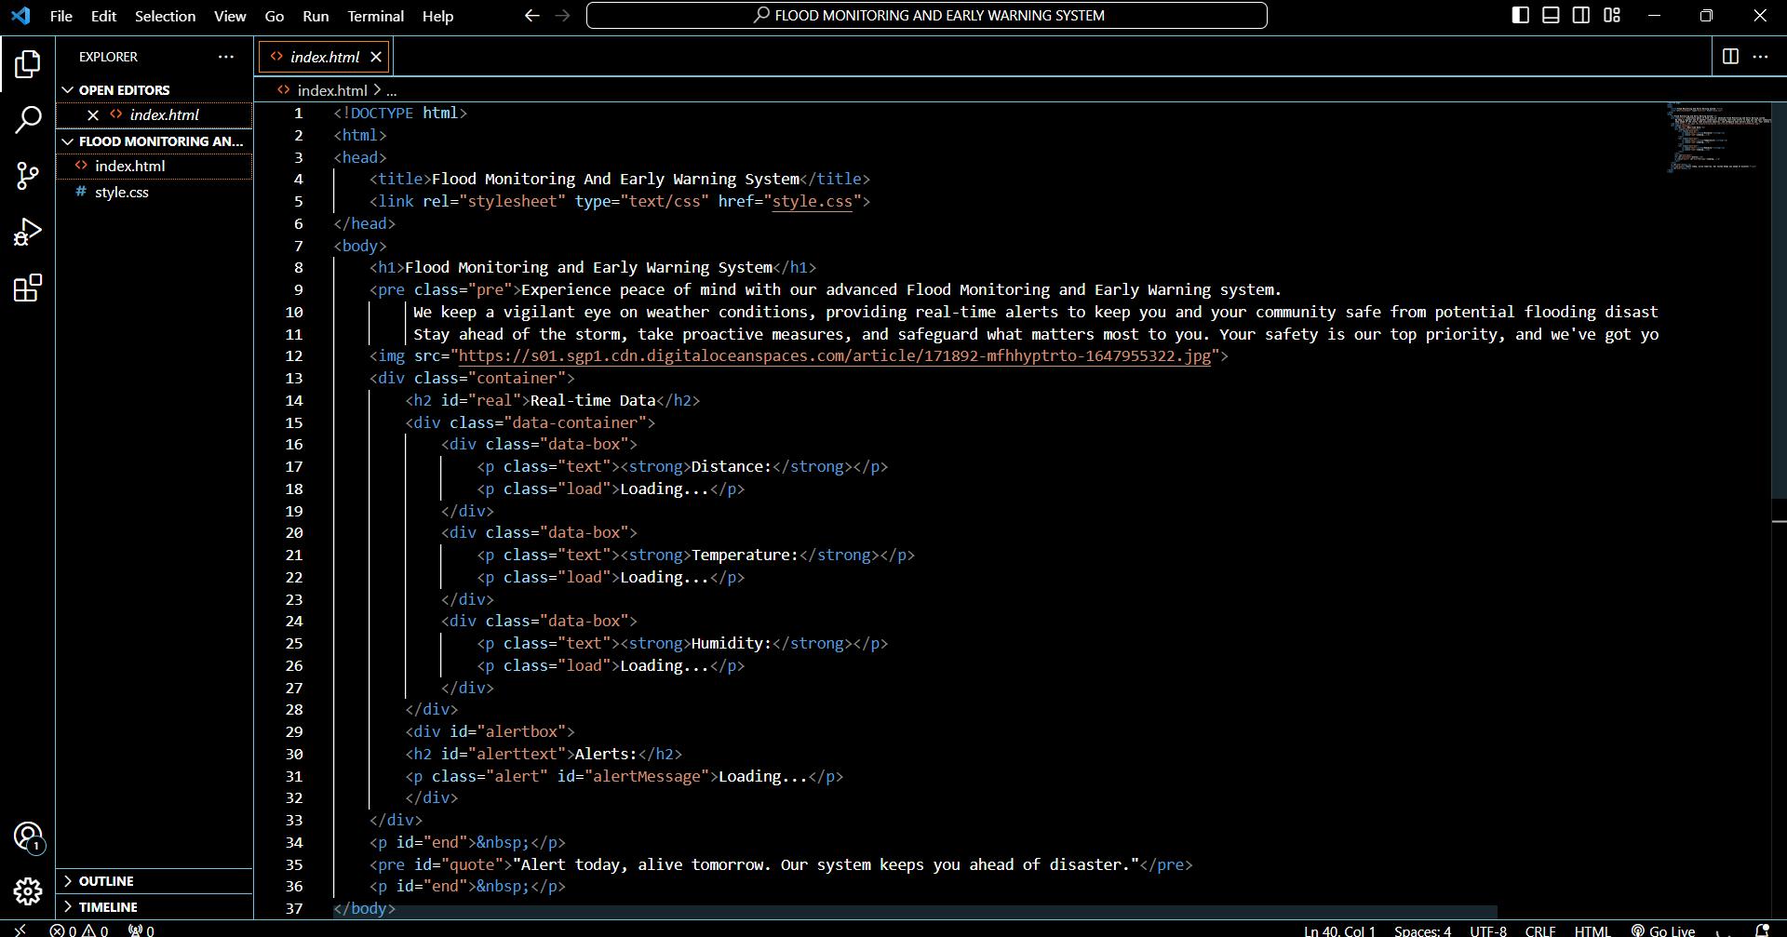

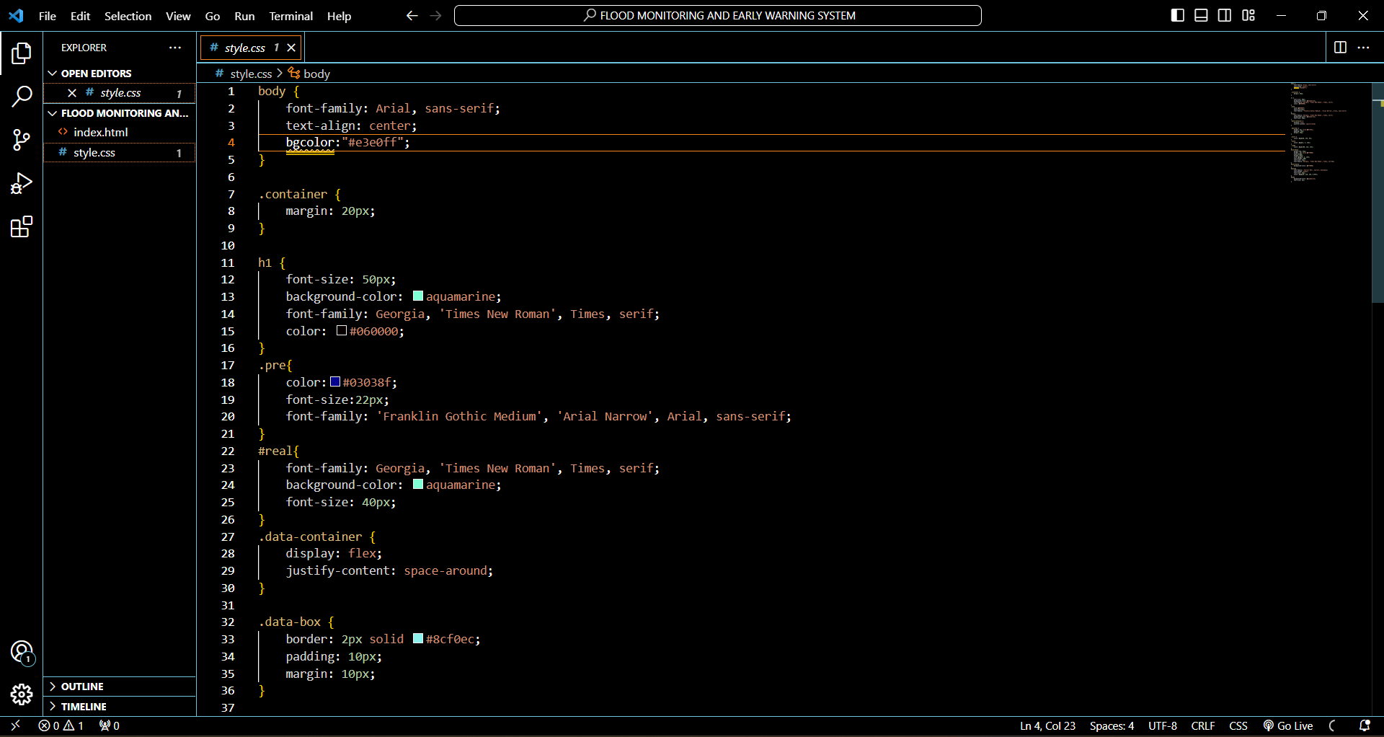

The provided HTML and CSS code collaboratively create a visually appealing and informative webpage for a "Flood Monitoring and Early Warning System." The HTML defines the content and structure of the page, while the CSS stylesheet provides the styling and presentation, resulting in an attractive and well-organized web interface. The webpage conveys essential information about the system's purpose and capabilities, displays real-time data, and provides alerts while offering an inspirational closing quote. This combination of well-structured content and visually appealing design makes the webpage engaging and effective in communicating its message.

**RESULT:**

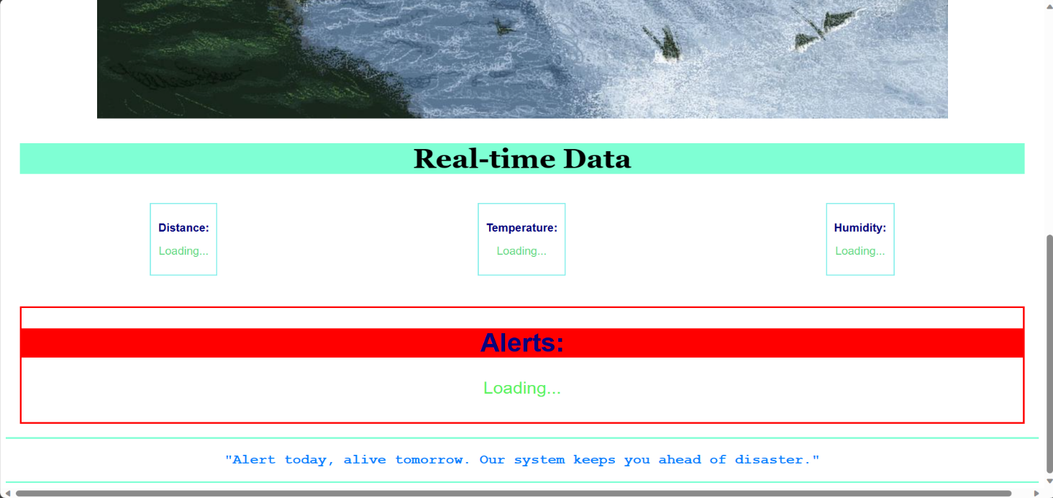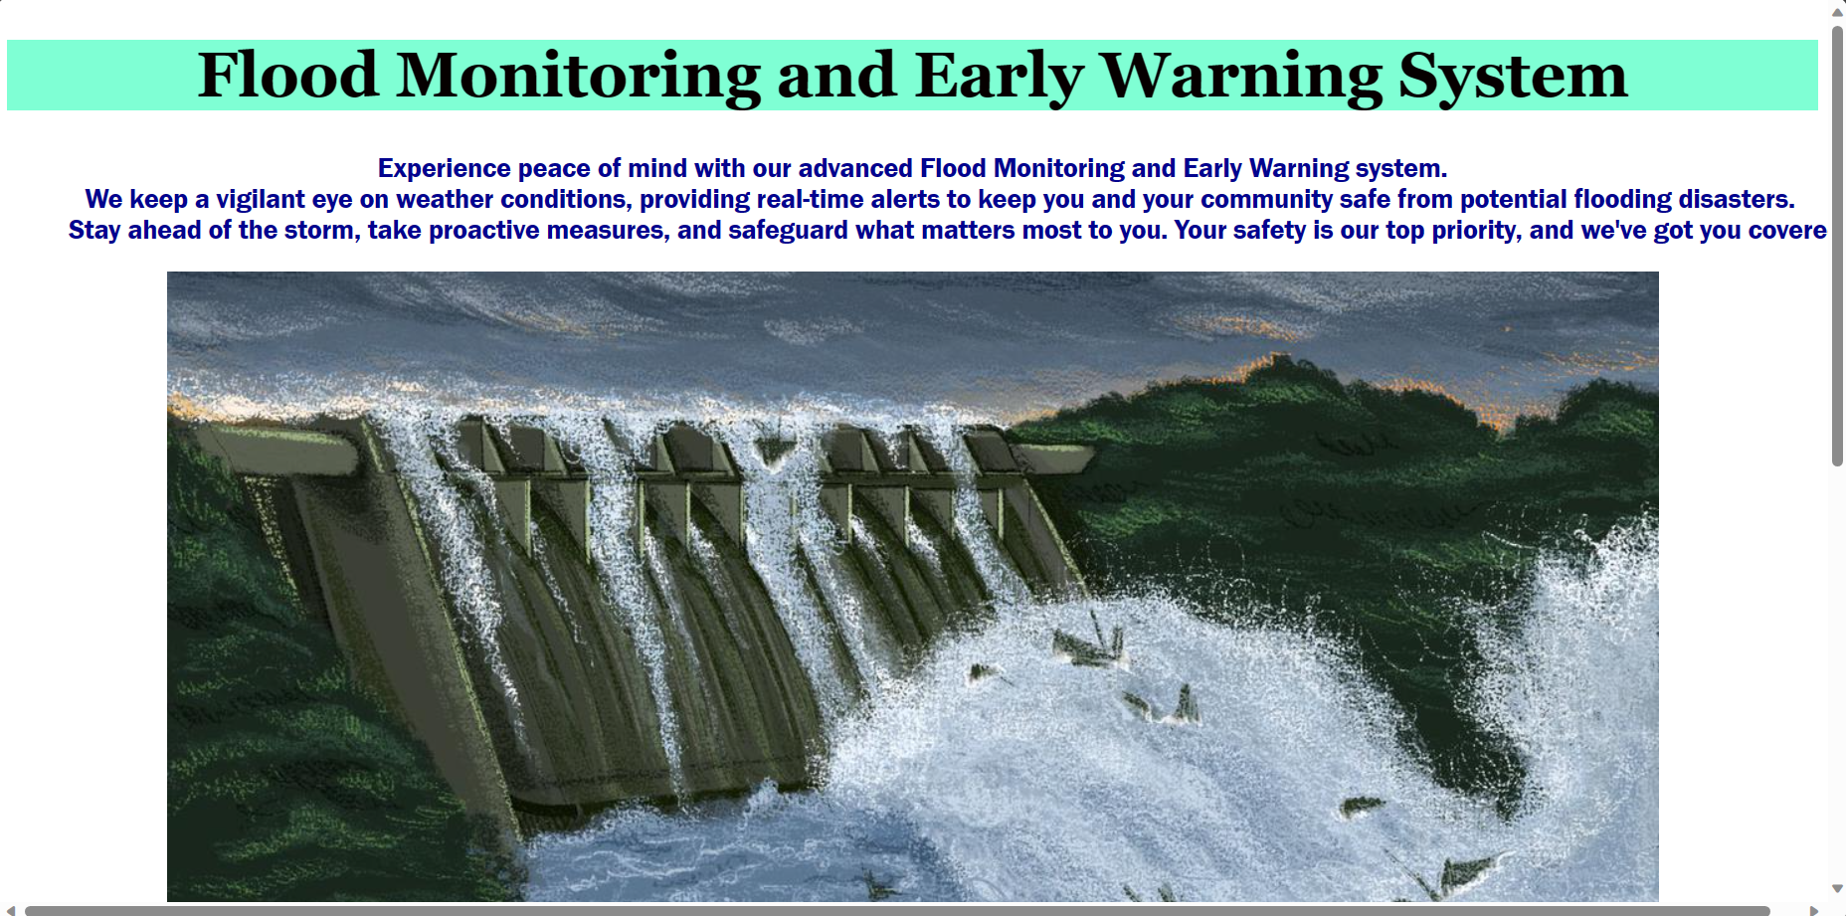

The provided HTML and CSS code results in a compelling webpage for a "Flood Monitoring and Early Warning System." The webpage encompasses several key elements: a prominent header that establishes the system's identity, a detailed description with line breaks for clarity, and a visually relevant image. The "Real-time Data" section is effectively structured, presenting data points within organized boxes that dynamically update. An "Alerts" section with a bold red message indicates flood detection. The webpage concludes with an inspirational quote. The CSS stylesheet enhances the visual appeal, ensuring a polished and user-friendly platform for comprehending the system's purpose and receiving timely flood alerts. This webpage serves as an essential component of the Flood Monitoring System, delivering critical information in a visually appealing and well-organized manner.

**CONCLUSION:**

The HTML and CSS code in this project presents a visually appealing solution for a "Flood Monitoring and Early Warning System." The webpage effectively conveys the system's purpose and functionality, engaging users with a compelling header, descriptive content, and real-time data display. The "Real-time Data" section showcases key metrics: "Distance," "Temperature," and "Humidity," providing a structured presentation. The dynamic "Alerts" section offers real-time flood detection updates with a bold red message. An inspirational quote at the end adds a motivational touch. The accompanying CSS stylesheet ensures a user-friendly layout and aesthetic appeal. In summary, this webpage is an essential component of the Flood Monitoring System, offering a polished and engaging platform for users to understand the system's purpose and receive timely flood alerts, contributing to public safety and awareness.